IT INTELLIGENT CAREER PLACEMENT MANAGEMENT SYSTEM

Deuli, Lydia Dani

BSc (Computer System and Network) Dissertation
Ardhi University
August 2026
IT INTELLIGENT CAREER PLACEMENT MANAGEMENT SYSTEM

By
Deuli, Lydia Dani

A Dissertation Submitted in fulfillment of the requirements for the degree of Bachelor of Science (Computer System and Network) of Ardhi University

Ardhi University
August 2026

DECLARATION
I, Deuli, Lydia Dani (31969/T.2023), hereby declare that this report is my own work and effort, the matter embodied in this dissertation has not been submitted to, and will not be submitted to, any other university to receive a similar or different degree. The work in this report was carried out in accordance with the Regulations of the Ardhi University.
I have faithfully acknowledged, given credit to, and referred to the research workers wherever their work has been cited in the text and the body of the dissertation. I further certify that I have not willfully lifted some other’s paragraph, text, data, result e.t.c. reported in the journals, books, magazines, reports, dissertations, thesis e.t.c. or available at web-sites and included them in this dissertation and cited them as my work.

Student’s Name Signature Date
Deuli, Lydia Dani ……………………. …………………..

The Berne Convention, the Copyright Act of 1999, and other international and national laws on intellectual property protect this dissertation’s copyrighted content. It may not be reproduced by any means, in full or in part, except for short extracts in fair dealings, for research or private study, critical scholarly review, or discourse with an acknowledgment, without the written permission of the Directorate of undergraduate Studies, on behalf of both the authors and Ardhi University.

CERTIFICATION
The undersigned certify that they have read and hereby recommend for acceptance by Ardhi University a dissertation titled: IT Intelligent Career Placement Management System, in fulfillment of the requirements for the degree of Bachelor of Science (Computer System and Network) of Ardhi University.

………………………………
Mr. Deusdedit Mwalongo
(Supervisor)

Date: ……………….

……………………………….
Mr. Alexander Moreka
(Supervisor)

Date: ……………….

ACKNOWLEDGEMENT
First and foremost, I give thanks to Almighty God for His guidance, protection, and strength throughout the entire period of working on this project. It is through His grace that I have been able to complete this work successfully, overcoming all challenges encountered along the way.
I would also like to sincerely express my heartfelt gratitude to my supervisors Mr. Alexander Moreka and Mr. Deusdedit Mwalongo for continuous guidance, support, and constructive feedback, which greatly contributed to the successful completion of this project.
Special thanks also go to my colleagues and friends for their encouragement, cooperation, and assistance during the development of this work.

LIST OF ABBREVIATIONS AND ACRONYMS
AI Artificial Intelligence
API Application Programming Interface
CSS Cascading Style Sheets
CV Curriculum Vitae
DB Database
DFD Data Flow Diagram
ERD Entity Relationship Diagram
FTP Field Training Programme
HTML HyperText Markup Language
ICPMS IT Intelligent Career Placement Management System
IT Information Technology
JS JavaScript
PHP PHP: Hypertext Preprocessor
SMS Short Message Service
SQL Structured Query Language
UAT User Acceptance Testing
UI User Interface
UML Unified Modeling Language
UX User Experience

ABSTRACT
This project presents the development of an IT Intelligent Career Placement Management System is designed to improve the management of internship and field training placement processes in higher learning institutions. The current manual methods used for placement are inefficient, time-consuming, and prone to errors, leading to difficulties in matching students with suitable organizations and managing placement records effectively. The system aims to provide a centralized digital platform that connects students, companies, and administrators to streamline placement activities.
The system was developed using Agile methodology to allow iterative development and continuous improvement based on user feedback. User requirements were gathered through literature review, interviews, and observation of existing placement processes. The system design was carried out using tools such as Data Flow Diagrams (DFD), Entity Relationship Diagrams (ERD), and UML diagrams. The system was implemented using web technologies including HTML, CSS, JavaScript, PHP, and MySQL database to ensure a responsive and database-driven application.
The output of this project is a functional web-based system that enables students to apply for internship and field training opportunities online, allows companies to post available positions, and helps administrators manage and monitor placement activities efficiently. The system improves communication, reduces paperwork, and enhances accessibility and efficiency in career placement management.

TABLE OF CONTENTS
DECLARATION i
CERTIFICATION ii
ACKNOWLEDGEMENT iii
LIST OF TABLE x
LIST OF FIGURE xi
CHAPTER ONE 1
INTRODUCTION 1
1.1 General Introduction 1
1.2 Statement of the Problem 2
1.3 Objectives 2
1.3.1 General Objective 2
1.3.2 Specific objective 2
1.4 Research Questions 3
1.5 Significance of the Study 3
1.6 Structure of the Report 3
CHAPTER TWO 5
LITERATURE REVIEW 5
2.1 Literature Review 5
2.2 Related Studies 5
2.3 Research Gap 8
CHAPTER THREE 11
METHODOLOGY 11
3.1 Introduction 11
3.2 Selected Methodology 11
3.2.1 General Methodology 11
3.2.2 Methodology for Gathering User Requirements 11
3.2.3 Methodology for System Design 12
3.2.4 Methodology for System Implementation 12
3.2.5 Methodology for System Testing and Validation 13
3.3 Methodology table 14
CHAPTER FOUR 15
SYSTEM ANALYSIS AND DESIGN 15
4.1 Introduction 15
4.2 Requirement Analysis 15
4.2.1 System Requirements 15
4.2.1.1 Data Requirement 15
4.2.1.2 Software Requirements 16
4.2.1.3 Hardware Requirements 17
4.2.2 User Requirement 17
4.2.2.1 Functional Requirement 17
4.2.2.2 Non-functional Requirement 18
4.3 System Design 19
4.3.1 System Architecture 19
4.3.2 Use case diagram 21
4.3.3 Entity Relationship Diagram (ERD) 21
CHAPTER FIVE 23
IMPLEMENTATION AND TESTING 23
5.1 Introduction 23
5.2 Implementation 23
5.2.1 Home Page 23
5.2.2 User Registration Module 24
5.2.3 Login Module 25
5.2.4 Student Dashboard 25
5.2.5 Company Dashboard 26
5.2.6 Administrator Dashboard 27
5.2.7 The internship opportunity management module 27
5.2.8 Internship Application Module 28
5.2.9 Student Profile and Curriculum Vitae (CV) Management Module 29
5.2.10 User Management Module 30
5.3 System Testing and Validation 31
5.3.1 Unit Testing 31
5.3.2 Functional Testing 32
5.3.3 Integration Testing 33
5.3.4 User Acceptance Testing (UAT) 34
CHAPTER SIX 35
RESULTS AND DISCUSSION 35
6.1 Introduction 35
6.2 Findings 35
6.3 Product 36
6.4 Goal Achieved 37
6.5 Challenges and Limitations 37
CHAPTER SEVEN 38
CONCLUSION AND RECOMMENDATION 38
7.1 Introduction 38
7.2 Conclusion 38
7.2.1 Conclusion on Identifying and Gathering User Requirements for the IT Intelligent Career Placement Management System 38
7.2.2 Conclusion on Designing the IT Intelligent Career Placement Management System 38
7.2.3 Conclusion on Implementing the IT Intelligent Career Placement Management System 39
7.2.4 Conclusion on Testing and Validating the IT Intelligent Career Placement Management System 39
7.3 Recommendations 39
7.4 Further Study 39
REFERENCES 41
APPENDIX 43

LIST OF TABLE
Table 2.1: literature table 9
Table 3.1: Methodology Table 14
Table 5.1: unit testing results 32
Table 5.2: Functional Testing Results 32
Table 5.3: Integration Testing Results 33
Table 5.4 :User Acceptance Testing Results 34

LIST OF FIGURE
Figure 4.1: system architecture 20
Figure 4.2: use case diagram 21
Figure 4.3: Entity Relationship Diagram (ERD) 22
Figure 5.1: home page 24
Figure 5.2: user registration page 25
Figure 5.3: login module 25
Figure 5.4: student dashboard 26
Figure 5.5: company dashboard 27
Figure 5.6: administrator dashboard 27
Figure 5.7: Internship Opportunity Management Module 28
Figure 5.8: Internship Application Module 29
Figure 5.9 :Student Profile and CV Management Module 30

CHAPTER ONE

INTRODUCTION

1.1 General Introduction
Information Technology has fundamentally transformed how organizations and institutions manage information, facilitate communication, and execute service delivery. Many educational institutions are now utilizing computerized systems to improve efficiency, reduce paperwork, and provide better services to students and administrators. According to UNESCO, digital technologies play an important role in improving learning systems, communication, and career development opportunities for students. In higher learning institutions, internship and field training programs are among the critical academic activities that help students gain practical knowledge and work experience before entering the job market.
Internship and field training placements provide students with opportunities to apply theoretical knowledge in real-world working environments. These programs help students develop technical skills, professional experience, communication abilities, and teamwork skills required across different organizations and industries. According to the International Labour Organization (ILO), work-based learning programs such as internships improve employability and prepare students for future careers by exposing them to practical working conditions. Therefore, the effective management of internship and field training placement is vital for both students and higher education institutions.
Despite the proven importance of internship and field training programs, many institutions still rely heavily on manual, paper-based methods to manage placement activities (Aparna & Vijayalakshmi, 2026). Students are often required to physically search for placement opportunities, submit hardcopy applications, and follow up manually for responses from organizations. This traditional approach is time-consuming, costly, and highly inefficient. In many situations, students experience severe delays in obtaining placement opportunities due to poor communication and the lack of a centralized placement management system (Ahmed, 2026). Furthermore, administrators face immense difficulties in monitoring student progress, verifying placement records, and generating accurate administrative reports.
The development of intelligent, web-based systems provides a highly effective solution to these career placement challenges (Hardison, 2026). Intelligent systems can dramatically simplify placement workflows by allowing students to apply for internship and field training opportunities online, while enabling host organizations to post available opportunities and manage applications digitally. Administrators can also monitor placement activities, manage student records, and communicate with users more efficiently. According to the World Bank, digital systems improve transparency, accessibility, and overall efficiency in education and employment-related services.
Therefore, this study proposes the development of an IT Intelligent Career Placement Management System for managing internship and field training placement activities. The proposed system will provide a centralized platform that connects students, host companies, and academic administrators to improve communication, simplify application processes, eliminate paperwork, and improve the overall management of career placement activities.

1.2 Statement of the Problem
Many universities and colleges still use manual methods to manage internship and field training placement activities. Students face challenges in searching for placement opportunities, submitting applications, and receiving placement feedback on time. The manual process leads to delays, loss of information, poor communication, and difficulty in managing student placement records effectively.
Existing systems in some institutions mainly focus on academic management and do not fully support intelligent career placement activities for internship and field training. Some systems lack online application features, proper communication channels, and centralized management of placement information. As a result, students and organizations experience inefficiency during the placement process.
To solve these challenges, this study proposes the development of an IT Intelligent Career Placement Management System that will automate internship and field training placement activities. The system will provide online application services, improve communication between users, simplify placement management, and enhance accessibility to placement opportunities.

1.3 Objectives

1.3.1 General Objective
The general objective of this project is to design and develop an IT Intelligent Career Placement Management System.

Specific objective
- To identify and gather user requirements for the IT Intelligent Career Placement Management System.
- To design the IT Intelligent Career Placement Management System.
- To implement the IT Intelligent Career Placement Management System.
- To test and validate the IT Intelligent Career Placement Management System

1.4 Research Questions
- What are the user requirements for the IT Intelligent Career Placement Management System?
- How can the IT Intelligent Career Placement Management System be designed effectively?
- How can the IT Intelligent Career Placement Management System be implemented to improve internship and field training placement management?
- How can the IT Intelligent Career Placement Management System be tested and validated

1.5 Significance of the Study
Upon completing this study, the following benefits are expected:
- The system will help students access internship and field training opportunities easily through an online platform.
- The system will help companies manage student applications and placement information efficiently.
- The study will reduce manual paperwork and improve placement management activities in institutions.
- The system will improve communication between students, companies, and administrators during placement processes.
- The project will contribute to the advancement of intelligent information systems in
education and career development management

1.6 Structure of the Report
This report is organized into seven chapters, each presenting a different aspect of the study and development of the proposed IT Intelligent Career Placement Management System.
Chapter One presents the introduction of the study. It includes the background of the study, statement of the problem, objectives of the study, research questions, significance of the study, scope of the study, and structure of the report.
Chapter Two presents the literature review related to the IT Intelligent Career Placement Management System. It discusses relevant concepts, existing systems, related studies, technologies used in career and internship placement, and the identified research gap.
Chapter Three presents the research methodology used to conduct the study. It describes the research approach, data collection methods, data analysis techniques, system development methodology, and tools and technologies used in the study.
Chapter Four presents the requirements analysis and system analysis of the proposed system. It describes the existing system, the proposed system, functional and non-functional requirements, feasibility analysis, and system requirements. It also presents relevant system analysis models.
Chapter Five presents the system design and implementation. It describes the system architecture, database design, user interface design, system modules, implementation technologies, and the major functionalities of the developed IT Intelligent Career Placement Management System.
Chapter Six presents the system testing, results, and discussion. It describes the testing methods used, including unit testing, functional testing, integration testing, and user acceptance testing. The chapter also presents the testing results, system performance, and discussion of the findings in relation to the study objectives.
Chapter Seven presents the conclusion and recommendations of the study. It summarizes the major findings, provides conclusions based on the objectives of the study, identifies limitations encountered during the development of the system, and provides recommendations for future improvements and further research.

CHAPTER TWO

LITERATURE REVIEW

2.1 Literature Review
A literature review is the systematic process of examining and analyzing previous studies, articles, books, and other scholarly materials related to a specific research topic. It helps the researcher to understand what has already been studied, identify existing research gaps, and gain critical knowledge about the methods and technologies used in similar studies. Literature review is important because it provides a strong theoretical and practical foundation for the study, avoids duplication of existing work, and helps the researcher improve the proposed system based on the weaknesses of previous studies.
In the context of higher education, the transition from manual administrative operations to web-based information systems can improve data management, reduce processing time, and enhance service delivery. Digital placement systems also support better communication between students, educational institutions, and organizations by providing centralized access to placement information and applications. Furthermore, the integration of Artificial Intelligence (AI), Machine Learning (ML), and Natural Language Processing (NLP) into career and internship systems can improve the process of matching students with suitable opportunities based on their qualifications, skills, and interests (Aparna & Vijayalakshmi, 2026; Hardison, 2026). These developments provide a foundation for integrating conventional placement management with intelligent recommendation features in the proposed IT Intelligent Career Placement Management System.

2.2 Related Studies
Lamin, Wan Jusoh, Samad, and Zainudin (2023) developed an Internship Placement Management System (IPMS) at Kolej Universiti Poly-Tech MARA (KUPTM) to improve the management of student internship placement activities. The system was designed to manage student information, internship applications and confirmation, student progress, academic supervisor assignment, performance evaluation, and reporting. The system works by providing different users with access to specific internship management functions, allowing internship coordinators to monitor students throughout the placement process. The system was developed using an evolutionary prototyping approach, while its web-based implementation used technologies such as Laravel, HTML, PHP, JavaScript, and MySQL. However, the system mainly focused on internship management and monitoring and did not provide intelligent recommendation features for automatically matching students with suitable internship opportunities.
Farkade, Rathod, Cheke, Bhondave, and Pawale (2024) developed a Training and Placement Management System to automate conventional training and placement activities in colleges. The system allows students to create accounts, update personal and educational information, upload resumes, access placement preparation materials, and submit queries. Companies can use the system to identify and shortlist eligible students according to their requirements. The system therefore works as a centralized platform connecting students, companies, and training and placement officers. The technologies used included HTML, CSS, Bootstrap, PHP, Android/XML, and MySQL. However, the system mainly focuses on general training and placement administration and does not provide an intelligent recommendation mechanism for automatically matching students with suitable opportunities based on their qualifications, skills, interests, and career preferences.
Sankoh, Kamara, Sesay, and Conteh (2026) developed a Web-Based Industrial Placement Management System for Milton Margai Technical University to automate industrial placement activities. The system provides functions for student registration, supervision, report submission, and performance evaluation. It works through a centralized platform connecting students, academic supervisors, and industry partners, allowing placement information and activities to be managed electronically. The system was developed using PHP, MySQL, HTML5, CSS3, and JavaScript, with a three-tier architecture separating the presentation, application, and database layers. RESTful APIs were also proposed to support communication between system components and possible integration with external systems. However, the system mainly focuses on industrial placement administration, supervision, and monitoring and does not provide intelligent recommendation features for matching students with suitable placement opportunities.
Dharun, Kiruba, Ajay, Abdul Haleem, and Balaji (2026) developed an AI-Based Internship Recommendation System to assist students in finding suitable internship opportunities. The system works by analyzing student profiles, including skills, academic records, preferences, and resumes, and comparing this information with available internship descriptions. Machine Learning and Natural Language Processing (NLP) techniques are used to improve the matching process by identifying relationships between student qualifications and internship requirements. The system therefore provides personalized internship recommendations instead of requiring students to manually search through available opportunities. However, the system mainly focuses on internship recommendation and does not provide a complete placement management platform with centralized administration, company management, application management, monitoring, and reporting functionalities.
Geethanjali, Karol, Vaishakh Pavan Ganesh, Reddy, and Bharathi (2025) investigated an AI-Based Internship Recommendation System designed to provide personalized internship recommendations to students. The system uses recommendation approaches such as content-based filtering, collaborative filtering, hybrid recommendation, semantic similarity, and feedback-based learning to compare student information with internship requirements. The study also explored semantic processing and the Google Gemini API to understand student skills and internship descriptions beyond simple keyword matching. The system therefore uses artificial intelligence to improve the relevance of recommended internship opportunities. However, the study focuses mainly on recommendation and does not provide a comprehensive placement management platform integrating students, companies, administrators, applications, notifications, and placement monitoring.
Kirthika (2026) proposed an AI-Based Internship Finder and Profile Analyzer to assist students in finding suitable internship opportunities and analyzing their profiles. The proposed system focuses on internship matching, profile analysis, skill-gap analysis, machine learning, recommendation, and career guidance. The system works by analyzing information about students and using intelligent techniques to identify internship opportunities that are relevant to their profiles. This approach demonstrates how artificial intelligence can support students in making better internship and career decisions. However, the proposed system focuses mainly on finding and recommending internships and does not provide a complete centralized management platform involving students, companies, and administrators.
Ogedebe et al. (2024) developed a Web-Based Student Industrial Work Experience Scheme (SIWES) Management System to automate university placement applications and logbook monitoring. The platform functions by streamlining administrative workflows, connecting students and coordinators, and facilitating both the online submission of placement applications and the digital monitoring of student logbooks. This system was built using PHP, MySQL, HTML, and JavaScript, though its primary weakness is that it lacks applicant shortlisting tools and employer-driven vacancy dashboards.

Mngwengwe and Lwakatare (2025) researched the digital transformation of university practical training and placement workflows to bridge communication gaps between academic institutions and external organizations. Their system works by connecting academic supervisors, students, and employers into a unified platform to streamline practical training logistics, coordination, and institutional reporting. Built using Java, Spring Boot, and PostgreSQL, the approach is limited by its heavy focus on high-level administrative reporting rather than offering dynamic student profile matching.
Patel et al. (2025) implemented a Centralized Campus Recruitment and Internship Portal to handle bulk recruitment processes and corporate partner drives. The platform operates by facilitating automated resume parsing, streamlining interview scheduling, and managing interactions during corporate recruitment drives using Python, Django, and SQLite. Despite these automation features, the system lacks specific workflows tailored for multi-tier field study tracking and ongoing academic supervision.
Kiprop et al. (2026) introduced an Automated Student Placement and Tracking Information System to handle placement allocation and monitoring. The system works by streamlining student placement allocation and delivering real-time status updates and notifications through an interactive web interface built with Node.js, Express, and MongoDB. Nevertheless, the system's weakness lies in its lack of integrated, robust role-based security layers for referees and third-party credential verification.

2.3 Research Gap
The reviewed studies demonstrate that web-based systems have improved internship and placement management by reducing manual work, centralizing information, supporting online applications, and improving communication and monitoring. Other recent studies have introduced Artificial Intelligence, Machine Learning, and Natural Language Processing to recommend suitable internship opportunities based on students' profiles, skills, qualifications, and interests. However, the reviewed systems generally focus either on placement management or intelligent recommendation, rather than integrating both capabilities into one centralized platform. Some systems also lack comprehensive company management, centralized administration, application tracking, notifications, reporting, and placement monitoring.
Therefore, this study proposes the development of an IT Intelligent Career Placement Management System (ICPMS) that integrates career and internship opportunity management with intelligent placement recommendations in one centralized platform. The proposed system will support student and company profiles, opportunity posting, online applications, application status management, centralized administration, communication, reporting, and intelligent matching of students with suitable career and internship opportunities.

Table 2.1: literature table
S/N | Author(s) and Year | Study Focus | Technologies / Approach Used | How the System Works | Identified Gap
1 | Lamin et al. (2023) | Internship Placement System | Laravel, PHP, MySQL | Manages profiles and applications. | Lacks intelligent matching.
2 | Farkade et al. (2024) | Training and Placement System | PHP, Bootstrap, MySQL | Manages resumes and shortlisting. | Lacks skill-based matching.
3 | Sankoh et al. (2026) | Industrial Placement System | PHP, MySQL, REST APIs | Supports supervision and reporting. | Lacks smart recommendations.
4 | Dharun et al. (2026) | AI Internship Recommender | Machine Learning, NLP | Matches profiles with job descriptions. | Lacks administrative management.
5 | Geethanjali et al. (2025) | AI Internship Recommender | Hybrid Filtering, Gemini API | Matches students with opportunities. | Lacks monitoring functions.
6 | Kirthika (2026) | AI Finder and Profile Analyzer | ML, Skill-Gap Analysis | Analyzes skills and suggests roles. | Lacks full placement management.
7 | Ogedebe et al. (2024) | Web-Based SIWES Management System | PHP, MySQL, HTML, JavaScript | Manages applications and logbooks. | Lacks shortlisting and vacancy dashboards.
8 | Mngwengwe and Lwakatare (2025) | Digital Practical Training and Placement System | Java, Spring Boot, PostgreSQL | Connects students, supervisors, and employers. | Lacks dynamic profile matching.
9 | Patel et al. (2025) | Campus Recruitment and Internship Portal | Python, Django, SQLite | Automates recruitment and interviews. | Lacks field study tracking.
10 | Kiprop et al. (2026) | Automated Student Placement and Tracking System | Node.js, Express, MongoDB | Allocates placements and sends updates. | Lacks robust role-based security.

CHAPTER THREE

METHODOLOGY

3.1 Introduction
This chapter explains the methods and steps used to build the IT Intelligent Career Placement Management System. In software engineering, choosing and explaining a clear research methodology is important to show how the system will be planned, designed, and verified (Williams, 2010). This chapter describes the overall development approach, the methods used to gather user requirements, system design techniques, implementation tools, and the strategies used for testing and validation. It also explains how each objective of the study will be met in a clear and organized way.

3.2 Selected Methodology

3.2.1 General Methodology
This study uses the Agile methodology to develop the IT Intelligent Career Placement Management System. Agile is a modern way of building software that focuses on making progress step-by-step. Instead of building the whole system at once, the software is built in small, working parts, and users give feedback throughout the process. According to Misra et al. (2012), Agile practices improve software quality by focusing on direct communication, quick prototypes, and close teamwork between developers and users.
The Agile methodology was chosen because it is flexible and makes it easy to make changes while building the system. It also keeps users involved, ensuring the final system meets the actual needs of students, host companies, and school administrators. Furthermore, Agile improves software quality because the developer can test, review, and improve the system at every step of development (Williams, 2010).

3.2.2 Methodology for Gathering User Requirements
To collect clear system requirements for the IT Intelligent Career Placement Management System, this study used two data collection methods literature review and questionnaire. The literature review was conducted by reviewing academic papers, journals, reports, and existing studies related to internship placement, career management, and intelligent placement systems. This was done during the initial stage of the study to identify existing approaches, system features, challenges, and gaps that could be addressed by the proposed system (Ibrahim et al., 2026). The questionnaire was administered to selected students and relevant university stakeholders to collect information about their experiences, challenges, and requirements regarding career and internship placement. The questionnaires were distributed during the requirements-gathering stage of the study, and the collected responses were analyzed to identify the functional and non-functional requirements of the proposed system
The methods were reliable because the literature review provided information from credible academic sources, while the questionnaire collected direct information from the intended users. Together, they helped ensure accurate and relevant system requirements.

3.2.3 Methodology for System Design
The system design was done using structured and object-oriented design tools, including Data Flow Diagrams (DFD), Entity Relationship Diagrams (ERD), and Unified Modeling Language (UML) diagrams. According to Ibrahim et al. (2026), using DFDs, ERDs, and UML diagrams together helps software designers clearly plan both how data moves and how the system behaves.
In this study, the DFD was used to show how data moves through different parts of the system. The ERD was used to design the database, showing how different tables such as students, companies, administrators, logbooks, and applications connect to each other. UML diagrams (like Use Case and Sequence Diagrams) were used to show how users will interact with the system step-by-step. These tools were chosen because they give a clear visual map of the system, making it easier to find and fix design mistakes before writing the code.

3.2.4 Methodology for System Implementation
The Agile methodology was used for system implementation because it supports iterative development, continuous improvement, and regular user feedback. Pressman and Maxim (2020) explain that Agile methodology promotes flexibility, incremental development, and continuous feedback throughout the software development process. Therefore, the system was developed in small stages involving planning, development, testing, and improvement based on the identified requirements. This approach allowed changes to be made whenever new requirements or problems were identified during development.
The system was implemented using HTML, CSS, JavaScript, PHP, and MySQL. Sotnik et al. (2024) explain that HTML and CSS are used to create web page structure and appearance, while JavaScript supports interactivity and input validation. In this system, PHP was used to process system logic and communicate with the database, while MySQL was used to store and manage data such as student profiles, company information, applications, and placement records. Welling and Thomson (2003) describe PHP and MySQL as suitable technologies for developing dynamic, database-driven web applications. The system was developed through modules such as user registration, student profiles, company opportunities, application management, placement management, notifications, and administrative management, which were progressively developed, tested, and integrated into the complete system.

3.2.5 Methodology for System Testing and Validation
To ensure that the IT Intelligent Career Placement Management System works correctly, reliably, and according to the specified requirements, several types of testing were conducted, including Unit Testing, Functional Testing, Integration Testing, and User Acceptance Testing (UAT). Unit testing was used to test individual system components or modules separately to ensure that each component performs its intended function correctly. Functional testing was conducted to verify that the main system functions, such as user registration, login, posting placement opportunities, applying for opportunities, and managing applications, operate according to the specified requirements. Integration testing was performed to ensure that different system modules work correctly together and that data can be transferred accurately between connected components, such as student applications, company placement activities, and administrator management. Finally, User Acceptance Testing (UAT) involved allowing selected students, company representatives, and university administrators to use the system and provide feedback on whether it meets their needs and expectations. These testing methods helped identify errors, verify system functionality, and validate that the developed system was ready for use. These testing methods are very important because they guarantee that the system works well, is secure, and is ready to be used by the school.

3.3 Methodology table

Table 3.1: Methodology Table
Specific Objective | Methodology / Approach | Tools / Techniques | Expected Output
To identify and gather user requirements for the IT Intelligent Career Placement Management System. | Literature Review and Questionnaire | Google Forms, academic papers, journals, existing system documents | Requirements specification document
To design the IT Intelligent Career Placement Management System. | Structured and Object-Oriented Design | Draw.io, Microsoft Visio, DFD, ERD, UML Diagrams | System design document
To implement the IT Intelligent Career Placement Management System. | Agile Methodology | HTML, CSS, JavaScript, PHP, MySQL, Visual Studio Code | Functional system prototype
To test and validate the IT Intelligent Career Placement Management System. | Software Testing and User Acceptance Testing (UAT) | Test Cases, Test Data, Selenium, User Feedback Forms | Test Results and Validation Report

CHAPTER FOUR

SYSTEM ANALYSIS AND DESIGN

4.1 Introduction
This chapter presents the systematic analysis and design phases of the proposed system. It outlines the foundational building blocks of the application, beginning with a detailed requirement analysis that defines both user and system constraints. Furthermore, it transitions into the structural and behavioral blueprint of the platform, detailing the system architecture and database design to illustrate how data flows and operates within the environment.

4.2 Requirement Analysis
Requirement analysis is the critical process of discovering, analyzing, defining, and documenting the services that a system must provide and the constraints under which it must operate (Sommerville, 2016). It bridges the gap between high-level system objectives and the concrete software implementation. To ensure the developed platform aligns perfectly with stakeholder expectations and technical boundaries, this analysis is explicitly divided into two major categories: user requirements and system requirements.

4.2.1 System Requirements
System requirements represent the detailed descriptions of the system's functions, services, and operational constraints that must be in place for the software to be successfully deployed and executed (Pressman & Maxim, 2020). These requirements dictate the technical environment required to sustain the platform's infrastructure. To provide a comprehensive overview of the technical ecosystem, these system requirements are categorized into three distinct areas: data requirements, software requirements, and hardware requirements.

4.2.1.1 Data Requirement
Data requirements define the structure, types, and sources of information that the system must capture, store, and process to run its business logic. For the IT Intelligent Career Placement Management System, data was systematically gathered from specific sources to design a realistic and functional database. The physical and institutional locations where this data was collected include the university's academic registrar office, the department of Information Technology, and registered host companies that frequently hire interns. The data was collected by reviewing physical and digital academic files, analyzing the existing curriculum structures, and studying official internship application templates and company requirement sheets. This process ensured that the system's database structure matches real-world academic and professional needs.
The system uses several primary types of data to run its operations:
- Student Profile Data: Consists of student names, registration numbers, contact details, IT skills, and academic performance metrics. This data is used to verify student accounts, build student profiles, and match them with suitable placement opportunities.
- Company/Employer Data: Includes company names, industry sectors, location, contact details, and available internship or job openings. This data is used to populate the job board and display available opportunities.
- Application Data: Encompasses application dates, uploaded resumes, and application status tracking (such as pending, accepted, or rejected). Employers and administrators to manage the placement process use this data.

4.2.1.2 Software Requirements
Software requirements specify the operating systems, development tools, languages, and database management systems required to develop and run the application smoothly (Kendall & Kendall, 2020).
The software stack utilized for this project includes:
- Windows 10/11 Operating System: Served as the primary development platform, providing the environment to run code editors and local server instances.
- XAMPP Control Panel (v8.x): An open-source local server package containing Apache and MySQL. It was used to host the web application locally and manage the database during development.
- PHP (Hypertext Preprocessor): The core server-side scripting language used to handle backend business logic, session management, and secure communication with the database.
- MySQL / MariaDB: The relational database management system used to create, update, and maintain the tables containing student, employer, and placement records.
- Visual Studio Code: The lightweight source-code editor used to write, debug, and manage the PHP, HTML, CSS, and JavaScript files.

4.2.1.3 Hardware Requirements
Hardware requirements outline the physical compute resources, memory, and storage specifications necessary to develop, host, and interact with the application without performance degradation (Stallings, 2016).
The hardware components utilized during development and testing consist of:
- Central Processing Unit (CPU): Intel Core i5 (or equivalent AMD Ryzen processor) clocked at 2.5 GHz or higher. This provided the computational power needed to run the XAMPP local server alongside the development IDE simultaneously.
- Random Access Memory (RAM): 8 GB DDR4 minimum. RAM allocation ensures smooth multi-tasking between web browsers, code editors, and the local MySQL server background processes.
- Storage (SSD): 256 GB Solid State Drive. High-speed storage was used to ensure quick boot times for development environments and instant read/write access to project files and database logs.
- Network Interface: Standard Wi-Fi or Ethernet adapter, used to download development dependencies, packages, and to test local network access to the application.

4.2.2 User Requirement
User requirements are high-level statements, often written in natural language with accompanying diagrams, detailing the services the system is expected to provide to its users and the constraints under which it must operate (Sommerville, 2016). They focus heavily on user interactions, workflows, and expectations. To clearly delineate what the system does versus how well it performs, user requirements are split into functional requirements and non-functional requirements.

4.2.2.1 Functional Requirement
Functional requirements define the specific behaviors, calculations, data manipulation, and processing that the system must execute to satisfy the user's explicit needs (Pressman & Maxim, 2020). They dictate what the application must do upon receiving specific inputs.
The core functional requirements of the system include:
- User Authentication and Authorization: The system must allow students, employers, and administrators to securely log in, log out, and access only their designated dashboards.
- Profile Management: Student users must be able to create, update, and maintain their profiles, including uploading resumes and listing core skill sets.
- Placement / Job Posting: Employer users must be able to post new career or internship opportunities, complete with descriptions, requirements, and deadlines.
- Application Tracking: Students must be able to apply for open placements, and the system must allow employers or administrators to update the application status (e.g., Approved/Rejected).
- Search and Filter Functions: The system must provide a search mechanism for students to filter available placements by industry, location, or required skills.

4.2.2.2 Non-functional Requirement
Non-functional requirements specify the quality attributes, operational characteristics, and resource constraints of the system, defining how well the system executes its functions (Sommerville, 2016).
The essential non-functional requirements for this system include:
- Security: The system must protect user data by hashing passwords using robust algorithms (such as password_hash() in PHP) and safeguarding against SQL injection via PDO prepared statements.
- Performance / Response Time: System pages, particularly the student and employer dashboards, should load within 3 seconds under normal local network conditions.
- Usability: The user interface must be clean, responsive, and intuitive, requiring minimal training for students and employers to navigate their dashboards.
- Availability: The local application must maintain high availability during testing hours, ensuring minimal crashes or unhandled server errors (such as uncaught PDO exceptions).
- Maintainability: The codebase must follow clean MVC or modular coding structures with clear commenting so that future developers can easily debug or extend the platform.

4.3 System Design

4.3.1 System Architecture
System architecture is the conceptual model that defines the structure, behavior, and more views of a system, mapping software components to their underlying hardware and operational frameworks (Bass, Clements, & Kazman, 2012). This design is included to provide a high-level visual blueprint of how data moves between the user interface, the application server, and the database storage layer. Its primary purpose is to ensure scalability, ease of debugging, and a clear separation of concerns throughout development.

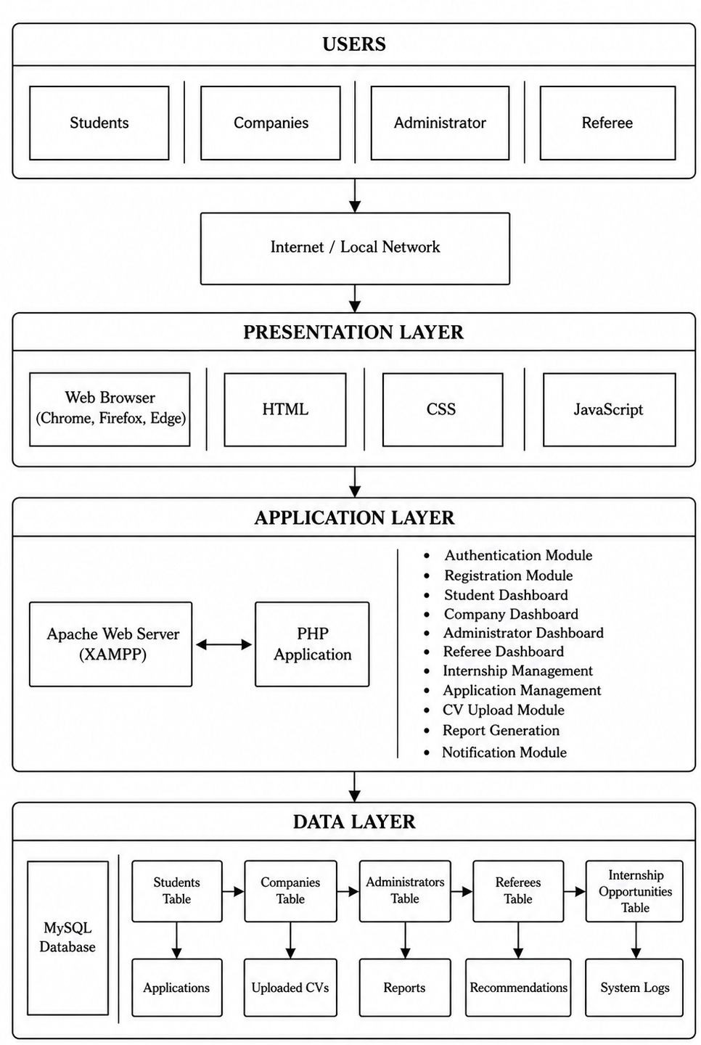

Figure 4.1: system architecture

4.3.2 Use case diagram
A use case diagram is a behavioral modeling tool used to illustrate the interactions between users (actors) and the system. It provides a high-level view of the functionalities offered by the system and identifies the roles involved in performing those functions. The use case diagram helps stakeholders understand the system's scope and the responsibilities of each user category before implementation begins (Sommerville, 2016).
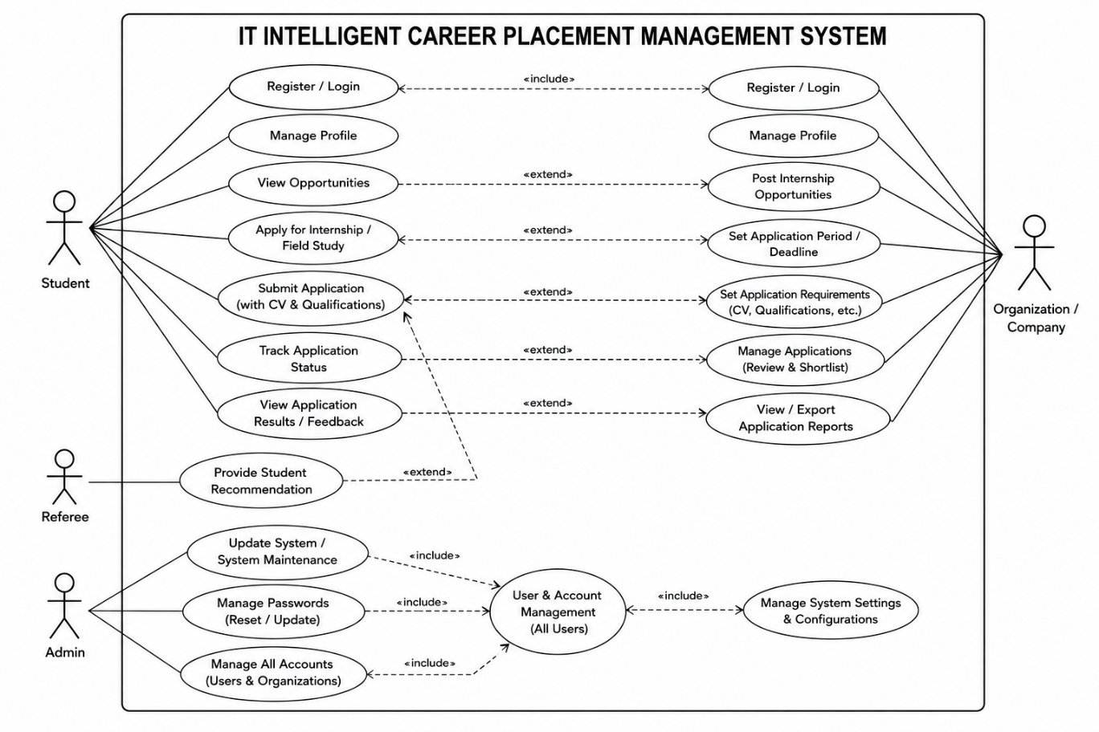

Figure 4.2: use case diagram

4.3.3 Entity Relationship Diagram (ERD)
An Entity-Relationship Diagram (ERD) is a structural blueprint that provides a visual representation of the system’s database tables, the attributes within those tables, and the precise logical relationships between those entities (Elmasri & Navathe, 2015). This design is included to serve as the foundational map for constructing the relational database in MySQL. Its purpose is to eliminate data redundancy, enforce referential integrity across foreign keys, and ensure efficient query execution when linking students, employers, and placement applications.

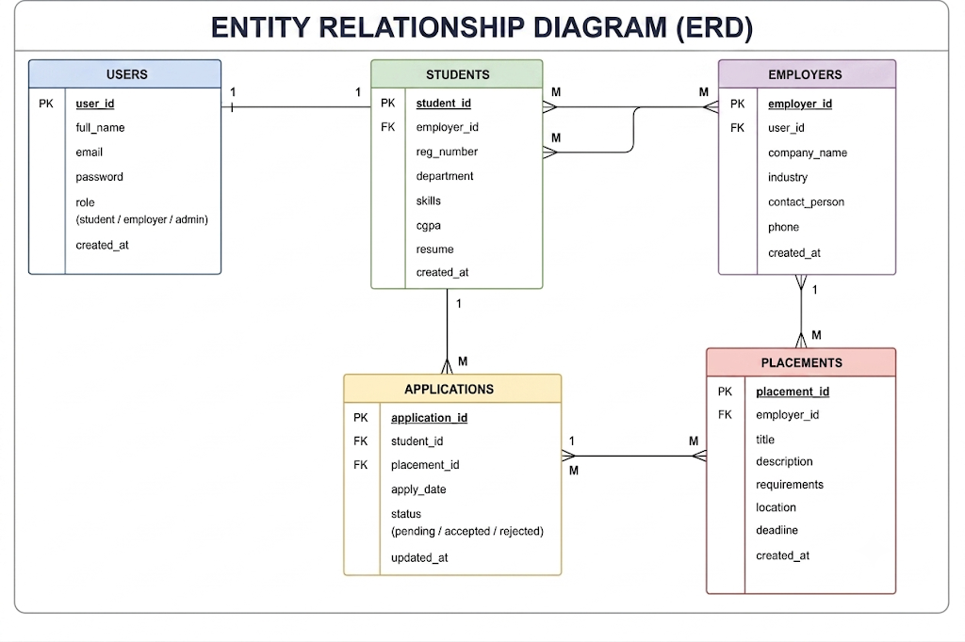

Figure 4.3: Entity Relationship Diagram (ERD)

CHAPTER FIVE

IMPLEMENTATION AND TESTING

5.1 Introduction
This chapter presents the implementation and testing of the IT Intelligent Career Placement Management System (ICPMS). It describes how the developed system was implemented based on the requirements gathered during the system analysis phase and the design developed in Chapter Four. The chapter explains the major modules of the system, their functionalities, and how they interact to facilitate internship and career placement management. Furthermore, the chapter presents the testing methods employed to verify that the system performs according to the specified functional and non-functional requirements before deployment.

5.2 Implementation
System implementation is the process of transforming the designed system into a operational software application. During this phase, the IT Intelligent Career Placement Management System was developed using HTML, CSS, JavaScript, PHP, and MySQL. HTML and CSS were used to create the user interface, JavaScript was incorporated to improve user interaction and responsiveness, PHP was used to implement the business logic and server-side operations, while MySQL served as the database management system for storing and retrieving application data. The system was deployed on the Apache web server provided by XAMPP to facilitate local development and testing. The implementation followed the Agile Software Development Methodology adopted in this study, allowing continuous improvement and refinement of the system throughout the development process.

5.2.1 Home Page
The home page serves as the entry point of the IT Intelligent Career Placement Management System. It provides users with general information about the system and allows easy navigation to different services including user registration, login, internship opportunities, and contact information. The interface was designed to be simple, attractive, and user-friendly to enable users to understand the purpose of the system without requiring technical knowledge. Clear navigation menus and organized content improve accessibility and enhance the overall user experience by allowing users to locate the required services quickly.
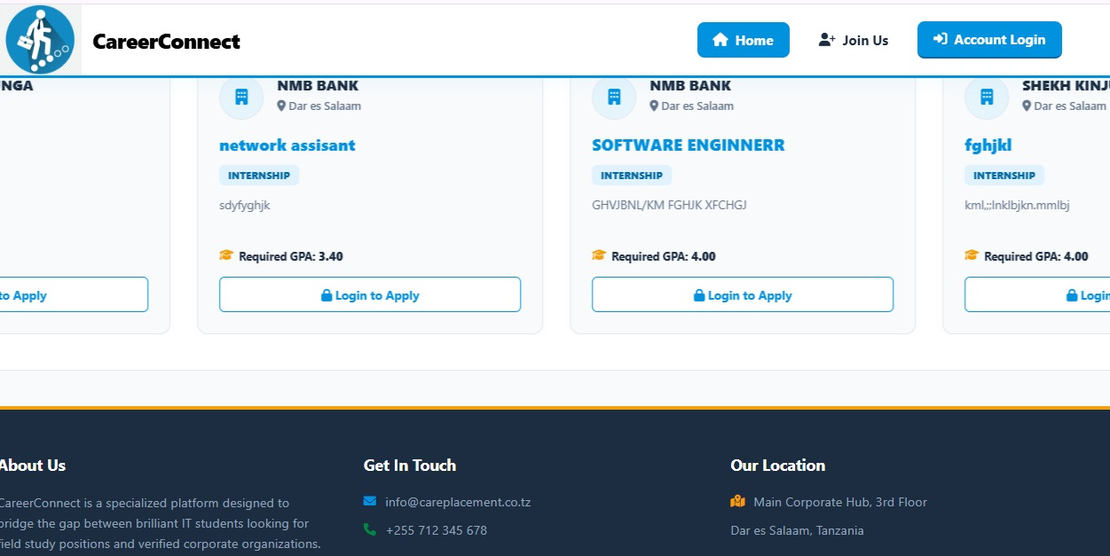

Figure 5.1: home page

5.2.2 User Registration Module
The user registration module enables students and company representatives to create user accounts before accessing the services provided by the system. During registration, users provide personal information including their full names, email addresses, usernames, passwords, and contact information. Before saving the information into the database, the system validates all mandatory fields to ensure data completeness and accuracy. Passwords are encrypted before storage to improve security and prevent unauthorized access to user credentials. Once registration is successfully completed, users are able to log into the system using the registered username and password to access their respective dashboards.
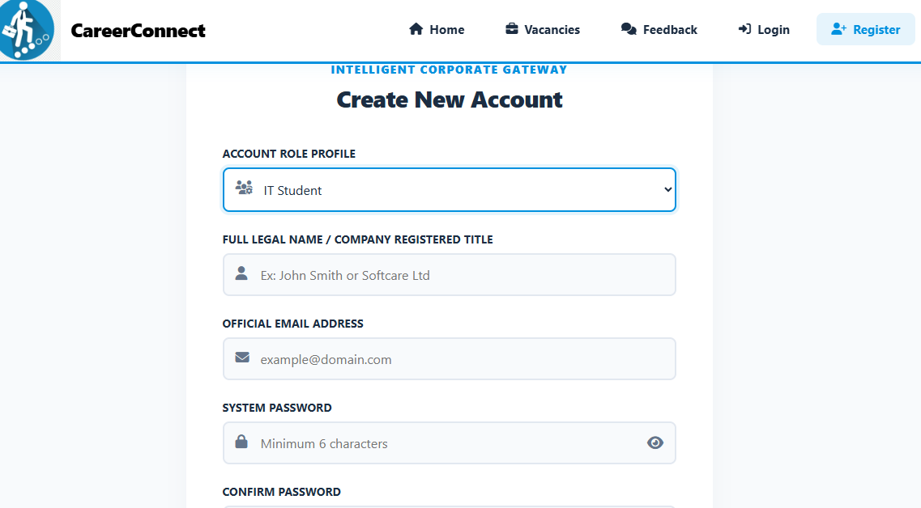

Figure 5.2: user registration page

5.2.3 Login Module
The login module is responsible for authenticating registered users before granting access to protected system resources. Users are required to enter their usernames and passwords, which are compared with encrypted credentials stored in the database. If authentication is successful, the system creates a secure user session and redirects the user to the appropriate dashboard based on the assigned role, namely student, company, or administrator. Invalid login credentials result in an appropriate error message while preventing unauthorized access to confidential information. This authentication mechanism strengthens system security by ensuring that only authorized users are allowed to access system resources (Pressman & Maxim, 2020).
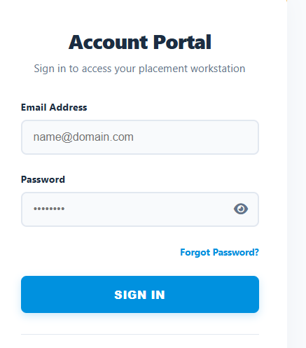

Figure 5.3: login module

5.2.4 Student Dashboard
The student dashboard serves as the primary workspace for students after successful authentication. It provides students with access to all services required during internship placement management through a centralized interface. Using this dashboard, students can update their personal profiles, upload Curriculum Vitae (CV), search available internship opportunities, submit internship applications, monitor application status, and receive important notifications from companies and administrators. The integration of these services into a single interface simplifies internship management and enables students to perform all required activities efficiently while minimizing manual procedures.
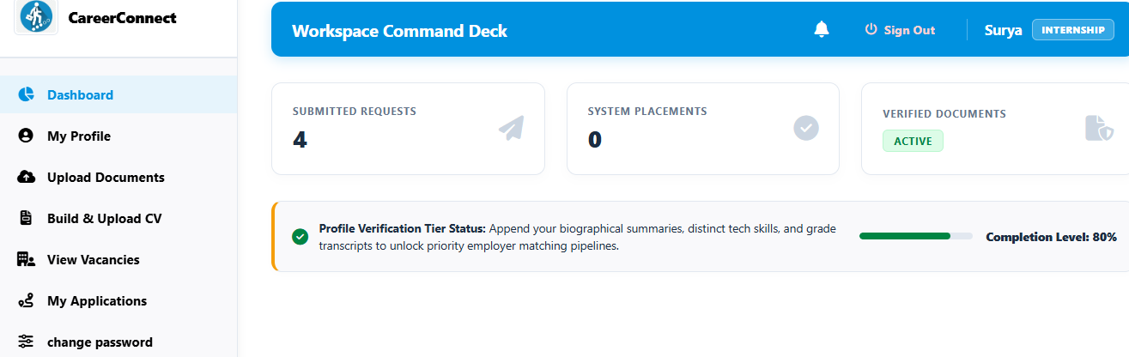

Figure 5.4: student dashboard

5.2.5 Company Dashboard
The company dashboard enables registered organizations to manage internship recruitment activities electronically. Through this module, organizations can create internship opportunities by providing details such as internship title, job description, qualifications required, location, and application deadline. Companies are also able to review applications submitted by students, examine applicant profiles, download uploaded Curriculum Vitae, and update application status by approving or rejecting applications. The dashboard simplifies communication between organizations and students while significantly reducing paperwork associated with traditional internship placement processes.
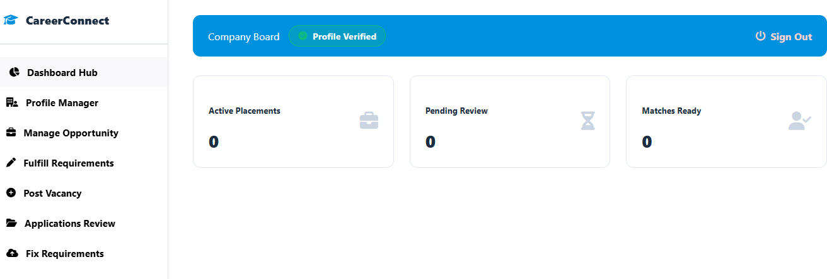

Figure 5.5: company dashboard

5.2.6 Administrator Dashboard
The administrator dashboard serves as the central management interface for the entire IT Intelligent Career Placement Management System. It enables administrators to monitor system operations and manage all registered users. Through this dashboard, administrators can approve company registrations, manage student accounts, oversee internship opportunities, monitor placement activities, generate reports, and perform other administrative functions necessary for maintaining the system. Centralizing these functions improves administrative efficiency and enables institutional management to monitor placement activities effectively.
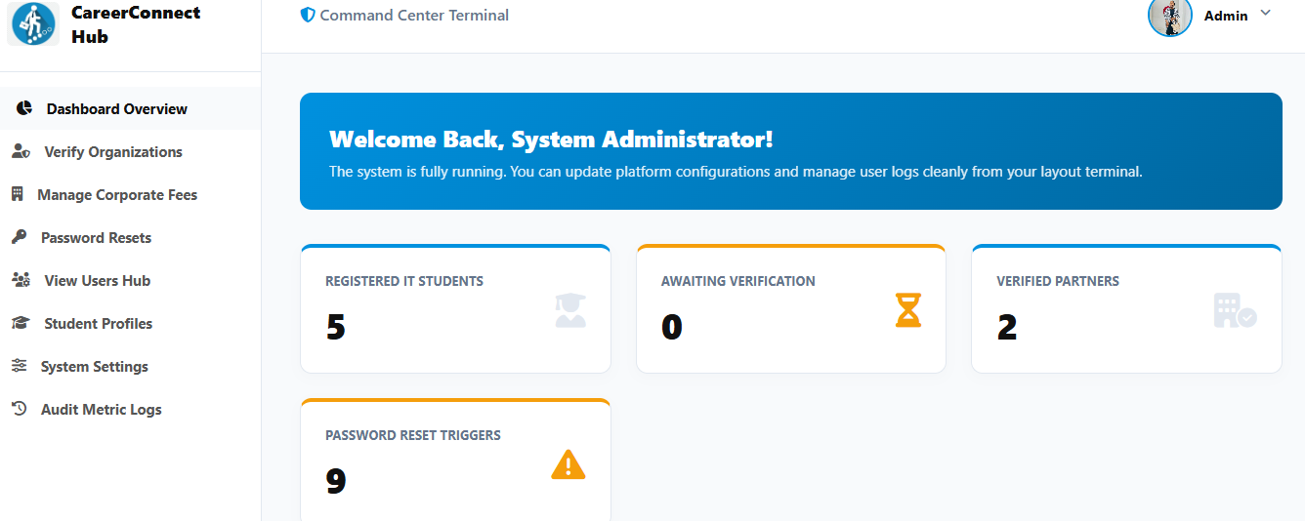

Figure 5.6: administrator dashboard

5.2.7 The internship opportunity management module
The internship opportunity management module allows registered organizations to advertise available internship positions through the system. Organizations enter detailed information regarding internship opportunities, including the position title, organization name, job description, required qualifications, internship location, and application deadline. Once published, the internship opportunities become immediately accessible to students, allowing them to search and apply electronically. This module improves accessibility to internship opportunities by replacing manual advertisement methods with a centralized online platform that can be accessed at any time.
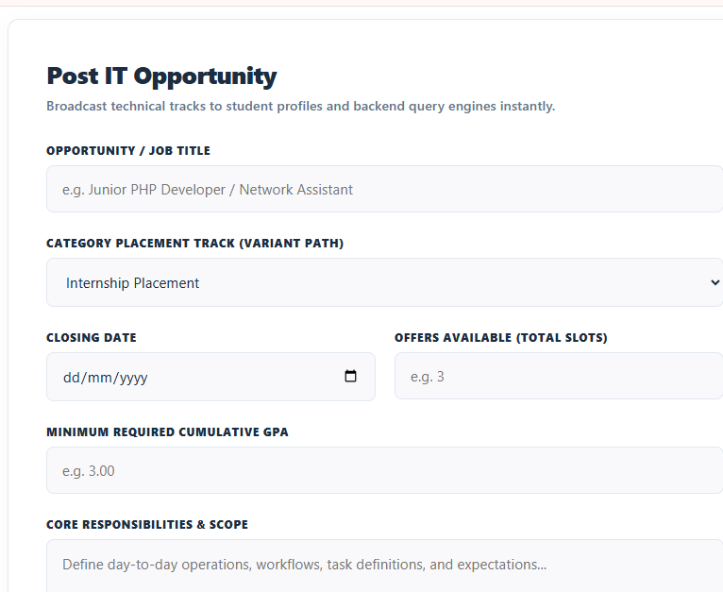

Figure 5.7: Internship Opportunity Management Module

5.2.8 Internship Application Module
The internship application module enables students to apply for internship opportunities electronically through the system. After identifying a suitable internship opportunity, students can submit their applications by completing the application form and attaching the required supporting documents, including their Curriculum Vitae (CV). Once the application has been submitted, the system automatically records the information in the database and forwards it to the respective organization for review. Company representatives can then evaluate the submitted applications and update their status as pending, approved, or rejected. Students are able to monitor these status updates through their dashboards, thereby improving transparency and reducing uncertainty throughout the internship placement process.
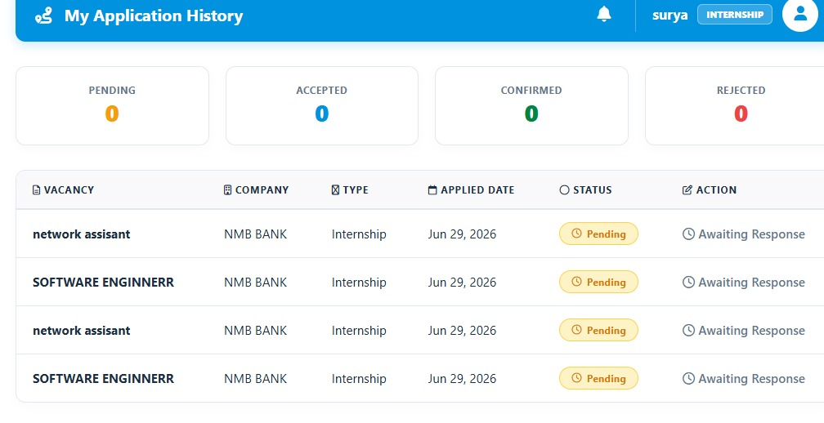

Figure 5.8: Internship Application Module

5.2.9 Student Profile and Curriculum Vitae (CV) Management Module
The student profile management module enables students to maintain accurate and up-to-date personal and academic information within the system. Students can update their personal details, educational background, contact information, technical skills, and career interests whenever necessary. In addition, the module allows students to upload or replace their Curriculum Vitae (CV), ensuring that organizations always receive the latest version during internship application review. Maintaining complete and updated student profiles enhances the effectiveness of internship matching and enables employers to make informed recruitment decisions based on current applicant information.
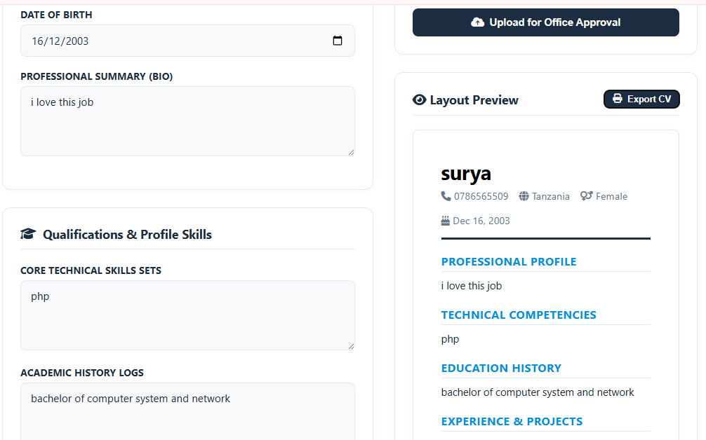

Figure 5.9 :Student Profile and CV Management Module

5.2.10 User Management Module
The user management module enables administrators to effectively manage all user accounts within the system. Through this module, administrators can create new accounts, edit user information, activate or deactivate accounts, reset user passwords, and remove inactive or unauthorized users. The module also supports role assignment, ensuring that users receive appropriate access privileges according to their responsibilities as students, company representatives, or administrators. Effective user management contributes to improved system security, accountability, and efficient administration of the entire application.
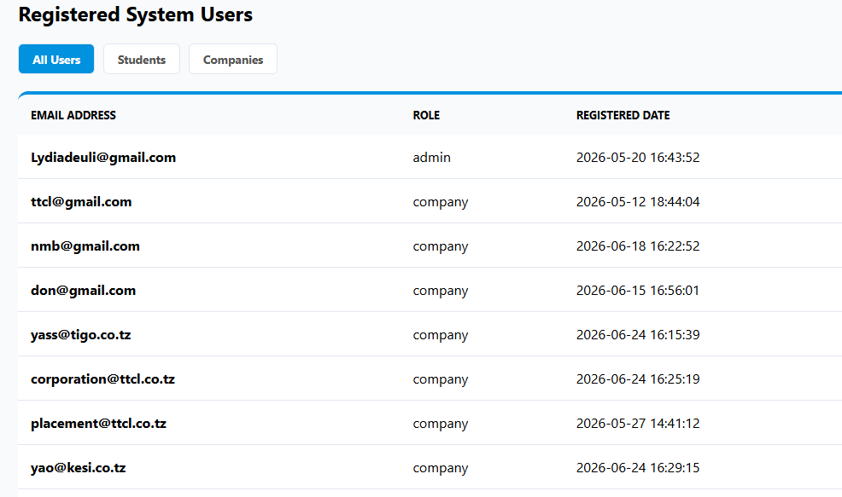Figure 5.10: User Management Module

5.3 System Testing and Validation
Software testing is a systematic process of evaluating a software system to determine whether it satisfies the specified requirements and operates correctly. In this study, four types of testing were conducted to evaluate and validate the IT Intelligent Career Placement Management System, namely Unit Testing, Functional Testing, Integration Testing, and User Acceptance Testing (UAT). Unit testing was used to verify individual system components, functional testing was used to confirm that system functions operated according to the specified requirements, integration testing was used to verify that different system modules worked correctly together, and User Acceptance Testing was conducted to determine whether the system satisfied the needs and expectations of its intended users. These testing methods helped identify errors, verify system functionality, and validate the overall performance and usability of the developed system.

5.3.1 Unit Testing
Unit testing was conducted to test individual components or modules of the system separately to ensure that each component performed its intended function correctly. The testing focused on individual functions such as user registration, login authentication, profile management, CV uploading, internship application, and report generation. Each component was provided with appropriate test inputs, and the actual results were compared with the expected results. The results showed that the individual components performed their intended functions correctly.

Table 5.1: unit testing results
S/N | System Component | Expected Outcome | Test Result
1 | User Registration | User information is successfully validated and stored | Passed
2 | Login Authentication | Valid credentials allow the user to access the system | Passed
3 | Profile Management | User information is successfully updated | Passed
4 | CV Upload | Valid CV file is successfully uploaded and stored | Passed
5 | Internship Application | Student application is successfully submitted | Passed
6 | Report Generation | Required report is generated correctly | Passed

The unit testing results indicate that the individual system components performed as expected and no critical errors were identified.

5.3.2 Functional Testing
Functional testing was performed to verify that the system functions operated according to the specified functional requirements. Each major function was tested using appropriate inputs, and the actual outputs were compared with the expected outcomes. The testing covered user registration, login, profile management, CV upload, internship opportunity posting, internship search, internship application, application status updates, report generation, and logout.

Table 5.2: Functional Testing Results
S/N | Functional Requirement | Expected Outcome | Test Result
1 | User Registration | User account created successfully | Passed
2 | User Login | User authenticated and redirected to the correct dashboard | Passed
3 | Profile Management | User profile updated successfully | Passed
4 | CV Upload | CV uploaded successfully | Passed
5 | Internship Opportunity Posting | Internship opportunity published successfully | Passed
6 | Internship Search | Available opportunities displayed correctly | Passed
7 | Internship Application | Application submitted successfully | Passed
8 | Application Status Update | Application status updated correctly | Passed
9 | Report Generation | Reports generated accurately | Passed
10 | Logout | User session terminated securely | Passed

The functional testing results indicate that all major functionalities of the system performed as expected and satisfied the identified functional requirements.

5.3.3 Integration Testing
Integration testing was conducted to verify that different modules of the IT Intelligent Career Placement Management System worked correctly when combined. The testing focused on the interaction between related modules and the proper flow of data between them. For example, the relationship between student profiles and internship applications was tested to ensure that applications were associated with the correct student. Similarly, internship opportunities posted by companies were tested to ensure that they were correctly displayed to students and that submitted applications were available to the relevant company and administrator.

Table 5.3: Integration Testing Results
S/N | Integrated Modules | Expected Outcome | Test Result
1 | Registration and Login | Registered users can successfully log in | Passed
2 | Student Profile and Application | Student information is correctly associated with applications | Passed
3 | Company Posting and Internship Search | Posted opportunities are correctly displayed to students | Passed
4 | Internship Application and Company Management | Submitted applications are correctly received by the company | Passed
5 | Application and Status Management | Updated application status is correctly displayed to the student | Passed
6 | System Data and Report Generation | Stored system data is correctly reflected in reports | Passed

The integration testing results showed that the connected modules communicated correctly and that information was transferred between the modules without significant errors.

5.3.4 User Acceptance Testing (UAT)
User Acceptance Testing (UAT) was conducted to determine whether the developed system met the needs and expectations of its intended users. Selected students, company users, and system administrators interacted with the system by performing common activities such as registration, login, profile management, internship posting, internship application, application status management, and report generation. Users provided feedback regarding the functionality, usability, reliability, and overall performance of the system.

Table 5.4 :User Acceptance Testing Results
S/N | Evaluation Area | Expected Outcome | User Feedback
1 | Ease of Use | Users can navigate the system easily | Accepted
2 | Registration and Login | Users can access the system successfully | Accepted
3 | Internship Management | Companies can manage internship opportunities | Accepted
4 | Internship Application | Students can apply for available opportunities | Accepted
5 | Application Tracking | Students can monitor application status | Accepted
6 | Report Generation | Administrators can generate required reports | Accepted
7 | Overall System Performance | System performs reliably during normal use | Accepted

CHAPTER SIX

RESULTS AND DISCUSSION

6.1 Introduction
This chapter presents the results and discussion of the IT Intelligent Career Placement Management System developed in this study. The findings are presented according to the four specific objectives of the study. The chapter also describes the final product obtained, explains the extent to which the study objectives were achieved, and presents the challenges and limitations encountered during the study.

6.2 Findings
The findings of this study are presented based on the four specific objectives that guided the development of the IT Intelligent Career Placement Management System.
To identify and gather user requirements for the IT Intelligent Career Placement Management System. The findings obtained through literature review and questionnaires identified the major requirements needed by students, companies, and administrators. These included student registration, profile management, CV uploading, viewing and searching for career and internship opportunities, application submission, company opportunity posting, application status management, notifications, and administrative management. The findings also identified non-functional requirements such as security, usability, reliability, and system performance. These requirements provided a clear foundation for designing and implementing the proposed system.
To design the IT Intelligent Career Placement Management System. The findings resulted in the development of a structured system design based on the requirements identified during the requirements-gathering stage. Structured and object-oriented design techniques were used to represent the system processes, data relationships, user interactions, and system architecture. Design models such as Data Flow Diagrams (DFD), Entity Relationship Diagrams (ERD), and Unified Modeling Language (UML) diagrams were developed to provide a clear representation of the proposed system. The completed design provided a blueprint for implementing the system and ensured that the identified requirements were properly incorporated.
To implement the IT Intelligent Career Placement Management System. The findings showed that the system was successfully implemented using the Agile methodology and web technologies including HTML, CSS, JavaScript, PHP, and MySQL. The developed system provides different functionalities for students, companies, and administrators. Students can create profiles, upload CVs, view available opportunities, and submit applications. Companies can post career and internship opportunities and manage applications, while administrators can manage users, monitor placement activities, and generate reports. The implementation therefore produced a functional system capable of supporting career and internship placement activities through a centralized platform.
To test and validate the IT Intelligent Career Placement Management System. The findings showed that the developed system was tested using Unit Testing, Functional Testing, Integration Testing, and User Acceptance Testing (UAT). Unit testing confirmed that individual system components operated correctly, while functional testing verified that the implemented functions met the specified requirements. Integration testing confirmed that different system modules communicated and exchanged data correctly. UAT involved intended users evaluating the system to determine whether it met their needs and expectations. The testing results showed that the major system functionalities operated successfully and that the developed system was suitable for its intended purpose.

6.3 Product
The IT Intelligent Career Placement Management System functions as a comprehensive, web-based platform engineered to modernize and streamline the internship and career placement lifecycle. Evaluated through the lens of implementation results and operational deployment, the platform successfully replaces fragmented manual workflows with a centralized, automated architecture. The system integrates distinct role-based access control, empowering students to seamlessly establish professional profiles, upload academic curricula vitae, discover targeted career opportunities, and submit real-time applications. Concurrently, participating corporate partners benefit from dedicated dashboards designed to facilitate organizational registration, profile optimization, vacancy postings, and applicant tracking. Furthermore, system administrators are equipped with robust oversight utilities to govern user permissions, audit placement progression, and generate analytical performance reports. Ultimately, the deployment outcomes demonstrate that the solution bridges the gap between academic institutions and industry partners, delivering a highly organized, accessible, and scalable digital framework for career management.

6.4 Goal Achieved
The overall goal of developing the IT Intelligent Career Placement Management System to enhance career and internship placement activities was successfully achieved through the completion of four specific objectives. Specifically, the study identified the necessary user and system requirements, designed the architecture utilizing appropriate design techniques, implemented the solution through suitable technologies combined with an Agile methodology, and thoroughly tested and validated the platform using diverse testing approaches. Consequently, the developed application resolves prior placement management challenges by supplying intended users with a centralized digital platform to efficiently coordinate and manage career and internship placement activities.

6.5 Challenges and Limitations
Despite the successful deployment of the IT Intelligent Career Placement Management System, the development and operational phases encountered notable technical and structural limitations. During the implementation process, the platform faced database integrity hurdles, including InnoDB file corruptions and engine-level table errors typically precipitated by abrupt service shutdowns or environment version mismatches. These technical roadblocks required rigorous troubleshooting and structural database repairs to ensure persistent data reliability. Additionally, the broader scope of deployment revealed operational friction, as transitioning institutional stakeholders away from deeply entrenched, fragmented methods—such as relying on social media groups and informal peer referrals—presented a challenge in achieving immediate, universal user adoption across all student bodies and corporate partners.
Furthermore, structural limitations remain regarding the system's current integration scope and feature scalability. Because the platform was engineered around specific initial requirements, it operates primarily as a standalone repository that does not yet feature automated third-party integrations with external university administrative databases or real-time corporate applicant tracking systems. This isolation requires administrators to manually audit and verify certain external credentials, thereby bounding the degree of total process automation. Addressing these constraints in future iterations will require expanding automated API integrations, reinforcing local server resilience against environment crashes, and implementing wider change-management strategies to secure sustained institutional engagement.

CHAPTER SEVEN

CONCLUSION AND RECOMMENDATION

7.1 Introduction
This chapter presents the conclusion and recommendations of the study on the IT Intelligent Career Placement Management System. The conclusions are presented based on the four specific objectives of the study. The chapter also provides recommendations for improving the developed system and identifies areas that require further study.

7.2 Conclusion
The study successfully developed an IT Intelligent Career Placement Management System to improve the management of career and internship placement activities. The system provides a centralized platform that enables students, companies, and administrators to manage placement activities more efficiently. The conclusions drawn from the study are presented according to the four specific objectives.

7.2.1 Conclusion on Identifying and Gathering User Requirements for the IT Intelligent Career Placement Management System
This objective was successfully achieved through literature review and questionnaires. The study identified the main requirements needed by students, companies, and administrators, including user registration, profile management, CV uploading, internship opportunity management, application submission, application tracking, notifications, and administrative management. The identified requirements provided a clear foundation for designing and developing a system that addresses the challenges associated with traditional career and internship placement processes.

7.2.2 Conclusion on Designing the IT Intelligent Career Placement Management System
This objective was successfully achieved through structured and object-oriented design approaches. DFD, ERD, UML diagrams, and system architecture were developed to represent system processes, data relationships, user interactions, and the overall system structure. The completed design provided a clear blueprint for implementation and ensured that the identified requirements were properly incorporated into the proposed system.

7.2.3 Conclusion on Implementing the IT Intelligent Career Placement Management System
This objective was successfully achieved using the Agile methodology and web technologies including HTML, CSS, JavaScript, PHP, and MySQL. The developed system enables students to create profiles, upload CVs, search for career and internship opportunities, and submit applications. Companies can post opportunities and manage applications, while administrators can manage users, monitor placement activities, and generate reports. Therefore, the implementation provided a centralized platform for improving career and internship placement management.

7.2.4 Conclusion on Testing and Validating the IT Intelligent Career Placement Management System
This objective was successfully achieved through Unit Testing, Functional Testing, Integration Testing, and User Acceptance Testing (UAT). The testing results showed that individual system components, major functions, and integrated modules operated according to the specified requirements. User Acceptance Testing further indicated that the system was understandable, usable, and acceptable to its intended users. Therefore, the developed system was successfully tested and validated for career and internship placement management.

7.3 Recommendations
The developed IT Intelligent Career Placement Management System is recommended for use by higher learning institutions to improve the management of career and internship placement activities. Institutions should provide adequate ICT infrastructure, train students, companies, and administrators on the use of the system, and conduct regular system maintenance and database backups. Appropriate security measures should also be implemented to protect users' personal and application information.
The system can be further improved by integrating email and SMS notification services, cloud deployment, and mobile application support. Artificial intelligence and machine learning capabilities can also be incorporated to provide intelligent recommendations by matching students with suitable career and internship opportunities based on their qualifications, skills, interests, and career preferences.

7.4 Further Study
Although the study successfully developed and tested the IT Intelligent Career Placement Management System, some areas remain for further investigation. The current system does not fully implement advanced artificial intelligence and machine learning algorithms for automatically matching students with the most suitable career and internship opportunities. Therefore, future studies should focus on developing intelligent matching algorithms based on students' academic qualifications, skills, interests, and career preferences. Further research may also investigate integration with university academic systems, employment platforms, mobile applications, and cloud services to improve the scalability, accessibility, and intelligence of the system.

REFERENCES
Ahmed, M. O., Neal, A. O., & Chizoba, C. E. (2026). A digital solution for student internship: Tracking and enhancing student’s experience. Asian Journal of Basic Science & Research, 8(1), 23–36. https://doi.org/10.38177/ajbsr.2026.8103
Bass, L., Clements, P., & Kazman, R. (2012). Software architecture in practice (3rd ed.). Addison-Wesley Professional.
Dharun, S., Kiruba, S., Ajay, A., Abdul Haleem, S., & Balaji, B. (2026). AI based internship recommendation system. Journal of Emerging Trends and Novel Research.
Elmasri, R., & Navathe, S. B. (2016). Fundamentals of database systems (7th ed.). Pearson.
Farkade, A., Rathod, A., Cheke, V., Bhondave, A., & Pawale, A. (2024). Training and placement management system. Journal of Harbin Engineering University, 45(3).
Geethanjali, B. S., Reddy, P. M., Karol, S., Vaishakh Pavan Ganesh, R., & Bharathi, R. J. (2025). AI-based internship recommendation system. In 2025 10th International Conference on Smart Structures and Systems (ICSSS) (pp. 1–6). IEEE. https://doi.org/10.1109/ICSSS66939.2025.11346221
Hardison, H., Mukhaiyar, R., Muskhir, M., Waskito, W., & Luthfi, A. (2025). Designing a web-based internship information system for vocational high schools. Jurnal Penelitian Pendidikan IPA, 11(2), 642–653. https://doi.org/10.29303/jppipa.v11i2.10227
Kendall, K. E., & Kendall, J. E. (2020). Systems analysis and design (10th ed.). Pearson.
Kirthika, S. (2026). AI based internship finder and profile analyzer. International Journal of Creative and Open Research in Engineering and Management, 2(6), 1–9. https://doi.org/10.55041/ijcope.v2i6.144
Lamin, N. Z., Jusoh, W. N. A. W., Zainudin, A. J. M., Samad, N. H. A., & Badari, K. A. (2024). Optimizing internship placement process: A study on the implementation of an internship placement management system (IPMS) at Universiti Poly-Tech Malaysia to improve efficiency and student experience. International Journal of Religion, 5(9), 882–895. https://doi.org/10.61707/cv6n4x15
Misra, S., Kumar, V., Kumar, U., Fantazy, K., & Akhter, M. (2012). Agile software development practices: Evolution, principles, and criticisms. International Journal of Quality & Reliability Management, 29(9), 972–980.
Pressman, R. S., & Maxim, B. R. (2020). Software engineering: A practitioner’s approach (9th ed.). McGraw-Hill Education.
Sankoh, A. S., Kamara, M. H., Sesay, A. B., & Conteh, E. (2026). Development and implementation of a web-based industrial placement management system for Milton Margai Technical University. International Journal of Computer Applications, 187(89), 46–52. https://doi.org/10.5120/ijca2026926565
Sommerville, I. (2016). Software engineering (10th ed.). Pearson Education Limited.
Sotnik, S., Manakov, V., & Lyashenko, V. (2023). Overview: PHP and MySQL features for creating modern web projects. International Journal of Academic Information Systems Research, 7(1), 11–17.
Stallings, W. (2016). Computer organization and architecture: Designing for performance (10th ed.). Pearson.
Welling, L., & Thomson, L. (2003). PHP and MySQL web development. Sams Publishing.
Williams, L. (2010). Agile software development methodologies and practices. Advances in Computers, 80, 1–44.

APPENDIX
QUESTIONNAIRE FORM STRUCTURE
Overview
This appendix outlines the questionnaire structure and options utilized for data collection during the research of the Intelligent Career Placement Management System.
Questionnaire Form
1. Full Name
  - [ Short answer text ]
2. Gender
  - [ ] Male
  - [ ] Female
3. Age Group
  - [ ] 18-22
  - [ ] 23-27
  - [ ] 28 and above
4. Role
  - [ ] Student
  - [ ] Company Representative
  - [ ] Administrator
5. Have you ever applied for internship or field placement online?
  - [ ] Yes
  - [ ] No
6. What challenges do students commonly face during internship placement?
[ Long answer text / Open-ended ] (Common responses included: getting a place, long waiting time for feedback, financial/transport issues, lack of supervision, and competition)
7. How do you currently receive internship opportunities?
  - [ ] Social Media
  - [ ] Friend/Colleagues
  - [ ] Company Website
  - [ ] University announcement
  - [ ] Notice Board
8. Do you think an online placement management system can improve the internship process?
  - [ ] Yes
  - [ ] No
9. Which feature would be most useful in the system?
  - [ ] Internship opportunity posting
  - [ ] Online application
  - [ ] Student profile management
  - [ ] Notifications and updates
  - [ ] Placement tracking
DATA VISUALIZATION
